# Familiar Functions - Python Exercise

Below is the image provided along with the recreated question, terminal output, and answer:

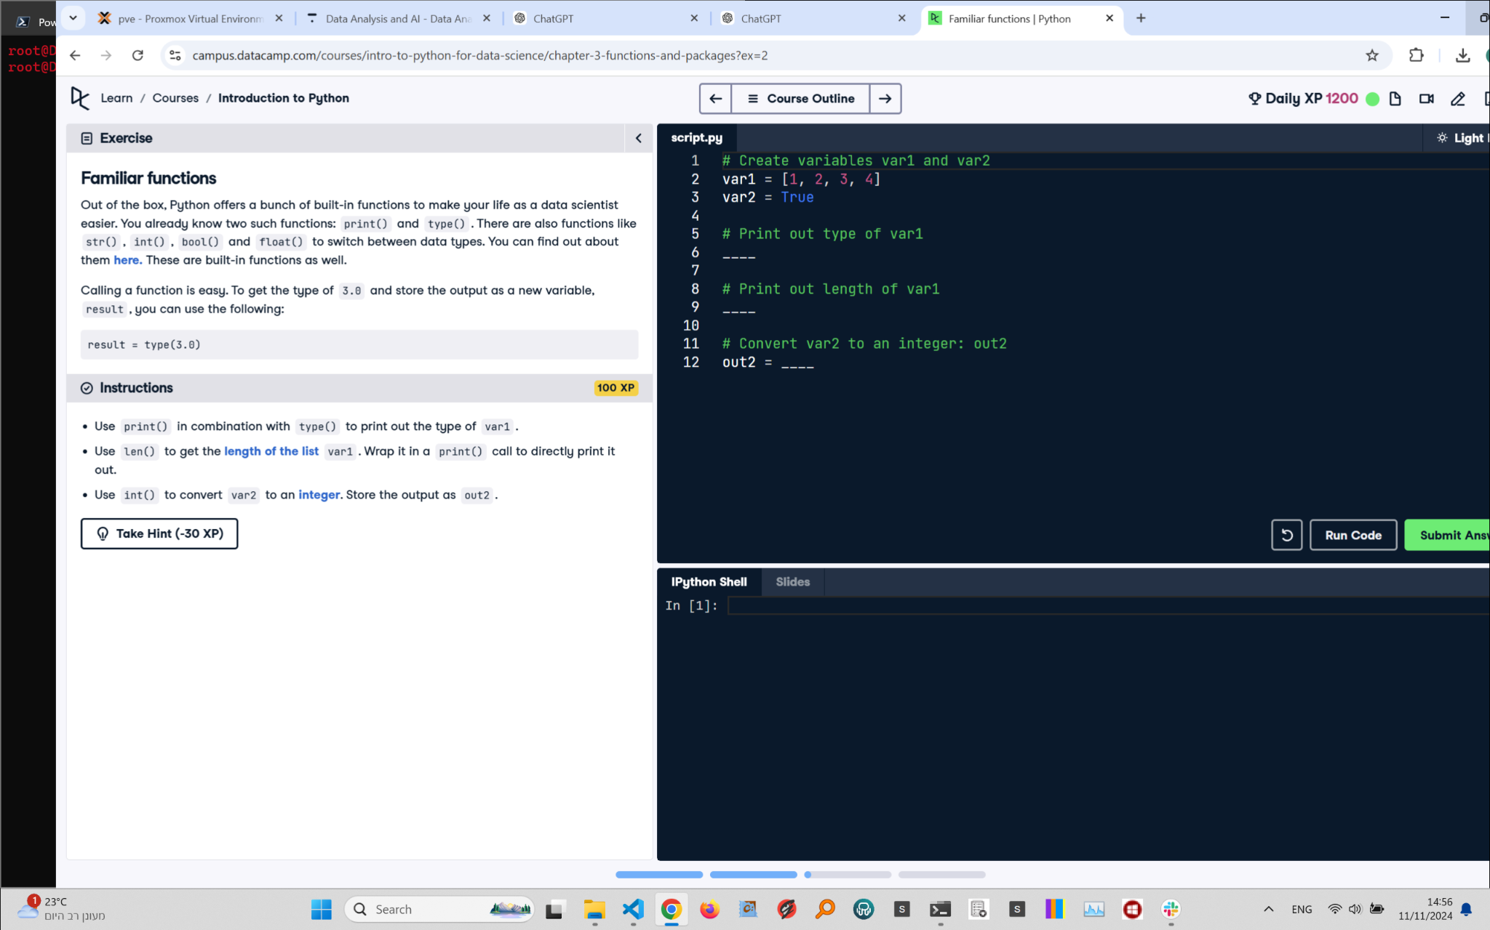

## Recreated Question and Terminal

Familiar Functions  
Out of the box, Python offers a bunch of built-in functions to make your life as a data scientist easier. You already know two such functions: print() and type(). There are also functions like str(), int(), bool() and float() to switch between data types.

Calling a function is easy. To get the type of 3.0 and store the output as a new variable, result, you can use the following:  
  
result = type(3.0)

Instructions:  
- Use print() in combination with type() to print out the type of var1.  
- Use len() to get the length of the list var1. Wrap it in a print() call to directly print it out.  
- Use int() to convert var2 to an integer. Store the output as out2.

## Answer

# Create variables var1 and var2  
var1 = [1, 2, 3, 4]  
var2 = True  
  
# Print out type of var1  
print(type(var1))  
  
# Print out length of var1  
print(len(var1))  
  
# Convert var2 to an integer: out2  
out2 = int(var2)  
  
# Print out2  
print(out2)

## Explanation of the Answer

The code uses type() to get the type of var1 and prints it. len() calculates the number of elements in var1, which is printed. int() converts the boolean var2 (True) to an integer (1), and the result is stored in out2 and printed.